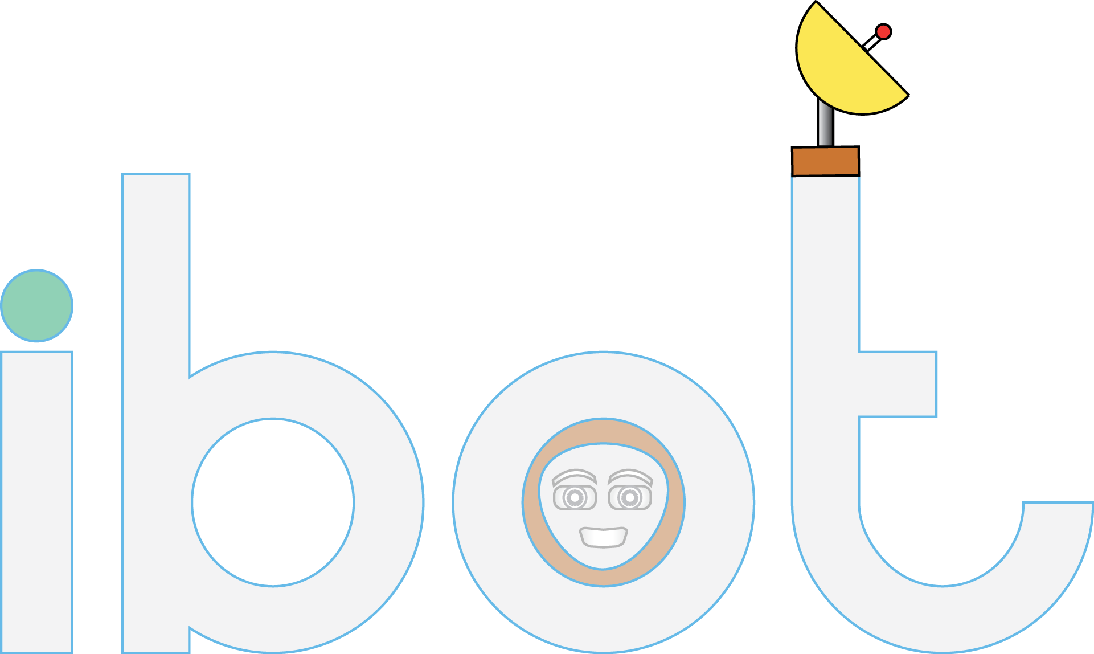

Made by:

Zeeshan Zulfiqar

2017-SE-106

Introduction

Ibot is basically a chatbot. A Chabot is a computer program which conducts a conversation via auditory or textual methods .tries to converse with human and performs some tasks along with it.

Scope

Chatbots can be used in variety of places for example marketing, customer service, personal assistant etc. it is an emerging field and more and more companies are deploying their personalized chatbot which represents the company. To add a more human flavor, machine learning and data science is being applied to the chatbot, however research is being held in this field continuously so after some time new technique is being deployed and experimented with. The most applausable instances of chatbot is siri, cortana, google assistant to name a few. As being said before the technique can be applied to any place and field and can give amazing results.

Implementations

* **JavaFx**
* **File Handling**
* **USING INHERITANCE,RETURING METHODS,USING THIS ,SUPER,FINAL KEYWORD**
* **Exception Handling**

Abilities

* Telling jokes.
* Maintaining flow of conversation.
* Have specific answers to broad spectrum question according to the context of the previous question asked by the user.
* Can tell jokes.
* Can tell the current time in all the countries.
* Can tell the currency and capital of any country.
* Can tell general knowledge stuff.

And much more…

Flow Diagram

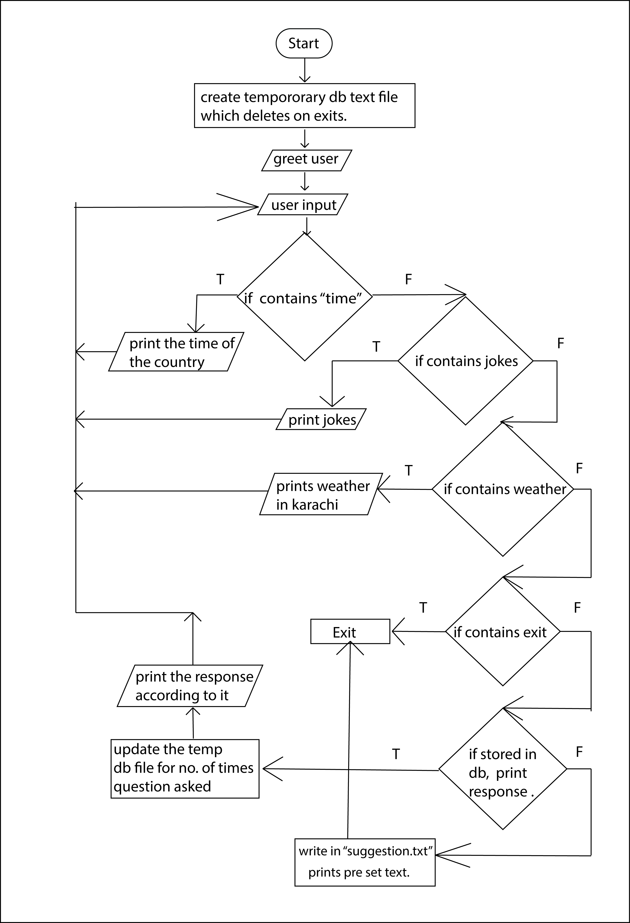

Advantages

The ibot provides a general framework with some functionalities. Its database can be modified for different audience and different functionality can be added easily.

Limitations

As with all softwares, ibot also has its limitation. If the user ask out of context things or thing that it isn’t programmed to do will not produce the desired output. Also the input can only be in English having correct spelling or else the program will not be able to recognize it.